TASK3 – rectangle-task

The only difference between this task and the last one (TASK2) is that this task has to have OOP principles. So this task has rectangle and rectangle class files.

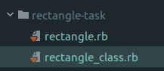

In *rectangle_class.rb* I’ve written a rectangle class, constructor for it to be called and methods.

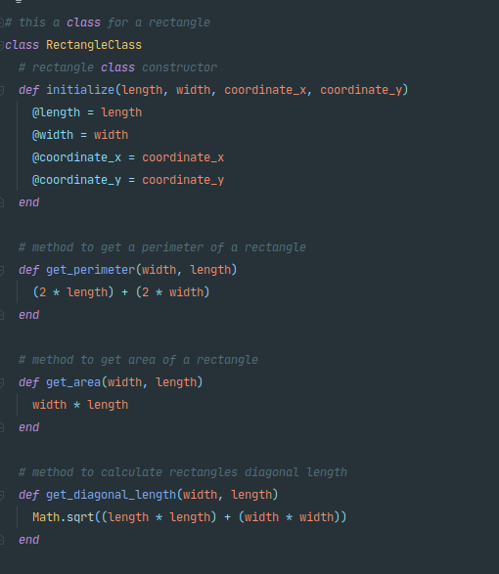

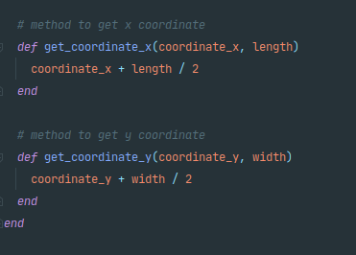

And this below is a *rectangle.rb* where we call our class and perform some calculations.

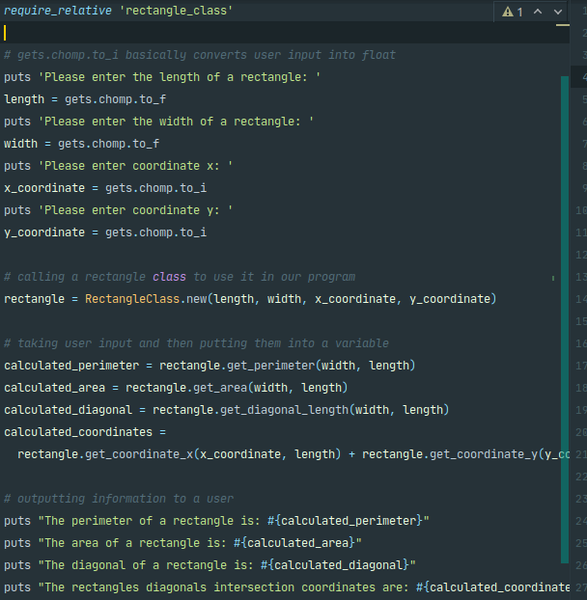

First we link our file that we’re going to import our class from. Then we get user inputs, we create an object of a rectangle and then we call our methods from the class.

Outputs are the same as in the previous task.

TASK3 – vigenere-cipher

Same goes with vigenere. We link our class file, get user input, then we create an object and perform needed methods. Easy as that.

Vigenere.rb:

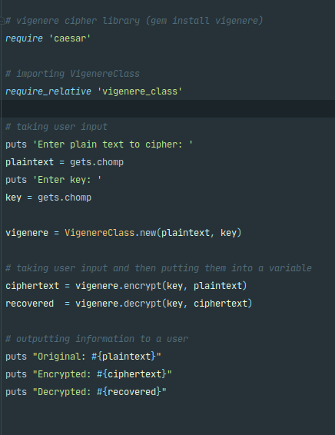

vigenere_class.rb: 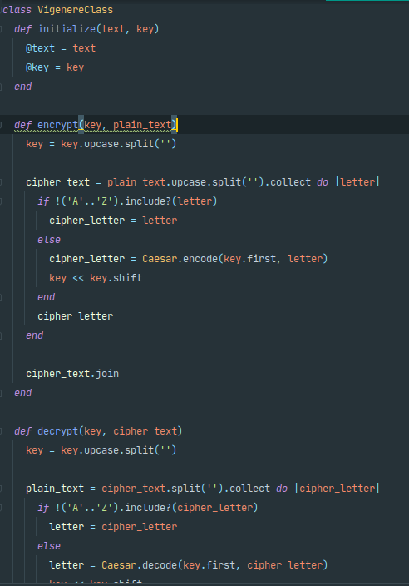

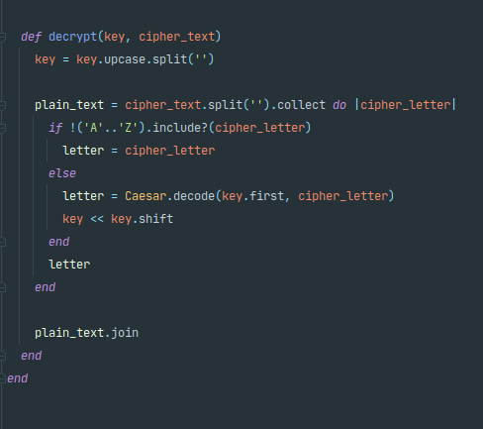

Outputs are the same as in the previous task.